Treasury Register
Interface walkthrough · every surface, what it is for, how to reach it
Sixteen screens · book dated 3 September 2026

This document is for reading before touching the app. It answers three questions for every surface: what am I looking at, which stage of the treasury process it serves, and what I can do there. It is organised front to back in the order the process itself runs, so a reader who is new to the app can follow the whole flow without needing to know the layout in advance.

The process the app supports
A treasury deal has a life. It is proposed, it is checked, somebody signs it, it accrues interest every night, a confirmation arrives from the counterparty, it may be amended, and at maturity three sources have to agree before it closes. The interface has one panel for each stage of that life, and the strip along the bottom cuts across all of them:
Stage | Where it lives on screen
Propose | Propose a Deal ticket, top right. The Six Checks live beside it.
Approve | Deal Blotter row → the deal panel opens → Approve button.
Accrue | Runs every night. Read the results in the deal panel's Recognised, per day section.
Confirm | The confirmation section of the deal panel. Mismatches also raise a Queue item.
Amend | The Amendments section of the deal panel. Raise, then apply.
Settle | The Settlement section of the deal panel. Three-way match.
Watch | The strip: Exposure, Queue, Breaches, Advisory, Ratings & Policy.

The strip stays at five items. Every new stage attaches to something already on screen — a section of the deal panel or a cause code in the queue — so navigation is one click deep for the whole run.

01. The sign-in screen
STAGE Before any process begins. Identity and segregation of duties.
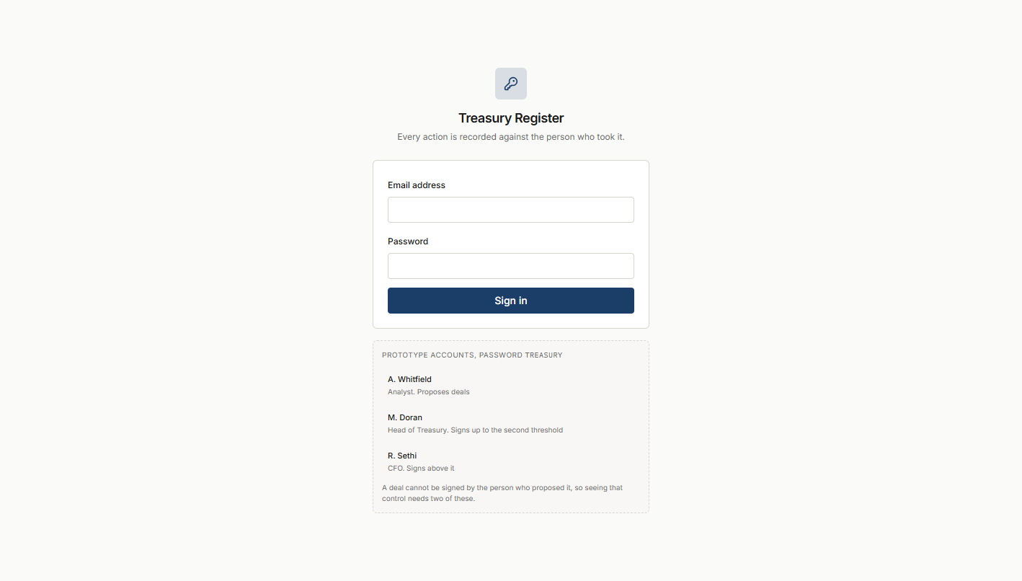
Figure 1. The sign-in screen.

What it is
The starting point. Three prototype accounts are shown so the tester can see the segregation-of-duties control without having to remember who is who: an analyst who proposes, a Head of Treasury who signs up to the second threshold, and a CFO who signs above it. The password for all three is treasury.

How to get here
Open http://localhost:3000 after start-all.bat has finished booting.

What you do here
- Sign in as any of the three accounts.
- The rule is on the screen: a deal cannot be signed by the person who proposed it, so demonstrating that control needs two of the three accounts.
- The token expires after twelve hours. Signing back in loses nothing.

02. The dashboard
STAGE The always-on view. Book on the left, ticket and checks on the right, blotter below, strip along the bottom.
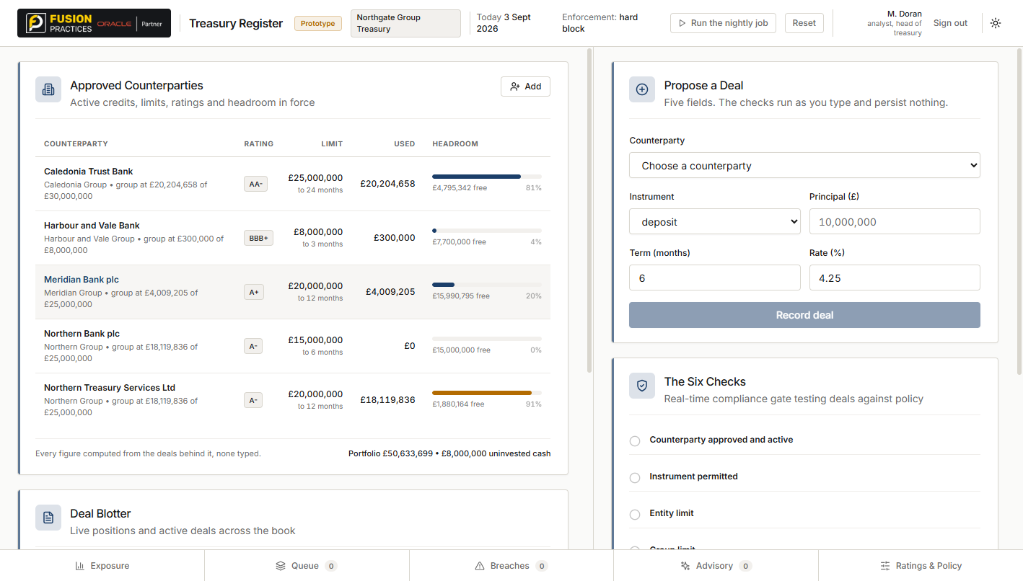
Figure 2. The dashboard.

What it is
The main screen. Everything else opens on top of this one, and closing any panel brings this back. Reading it left to right: Approved Counterparties (the book), then Propose a Deal (the ticket) and The Six Checks (the verdict), and along the bottom Deal Blotter with every live position. Along the very bottom is the strip of five panels.

How to get here
You are here after signing in. Every panel closes back to this view.

What you do here
- Read the book: which counterparties are approved, at what rating, with what limit, how much of the limit is used, and how much headroom is left. The %s below headroom shows utilisation at a glance.
- Read the blotter: the live positions on the book, each showing its measured value (principal plus accrued interest) and stage in its lifecycle.
- Notice the header: Prototype badge, tenant name, today's date, the enforcement policy in force, and the two demonstration buttons Run the nightly job and Reset.

03. Propose a Deal — the ticket, and a passing verdict
STAGE The propose stage. This is where a new position is keyed and tested against policy before it becomes real.
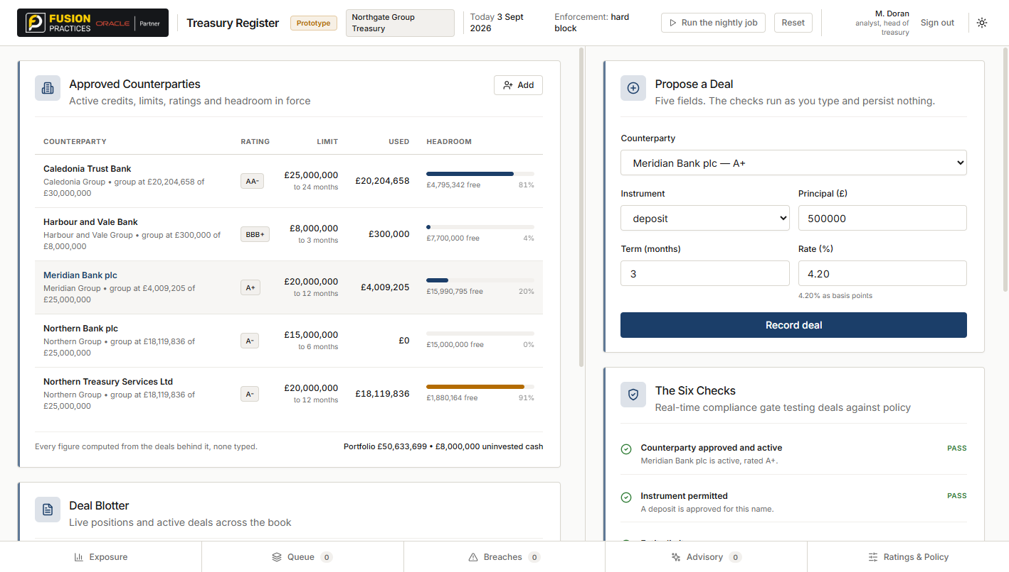
Figure 3. Propose a Deal — the ticket, and a passing verdict.

What it is
The right column of the dashboard. Five fields: Counterparty, Instrument, Principal, Term, Rate. The Six Checks panel beside it shows the verdict live, updating as you type. Nothing is saved and nothing is submitted until the Record deal button is clicked.

How to get here
The dashboard, always visible. It is never behind a panel.

What you do here
- Type a deal in. Each check states its arithmetic as it runs, so a passing verdict shows why it passed, not only that it did.
- Click Record deal when every check is green. The deal appears in the Deal Blotter at stage awaiting approval.
- Nothing is persisted until you click Record. The screen is a sandbox in every sense.

04. Propose a Deal — a failing verdict, with a resize offered
STAGE Still the propose stage. The refusal case, where one check fails and the system offers a fitting alternative.
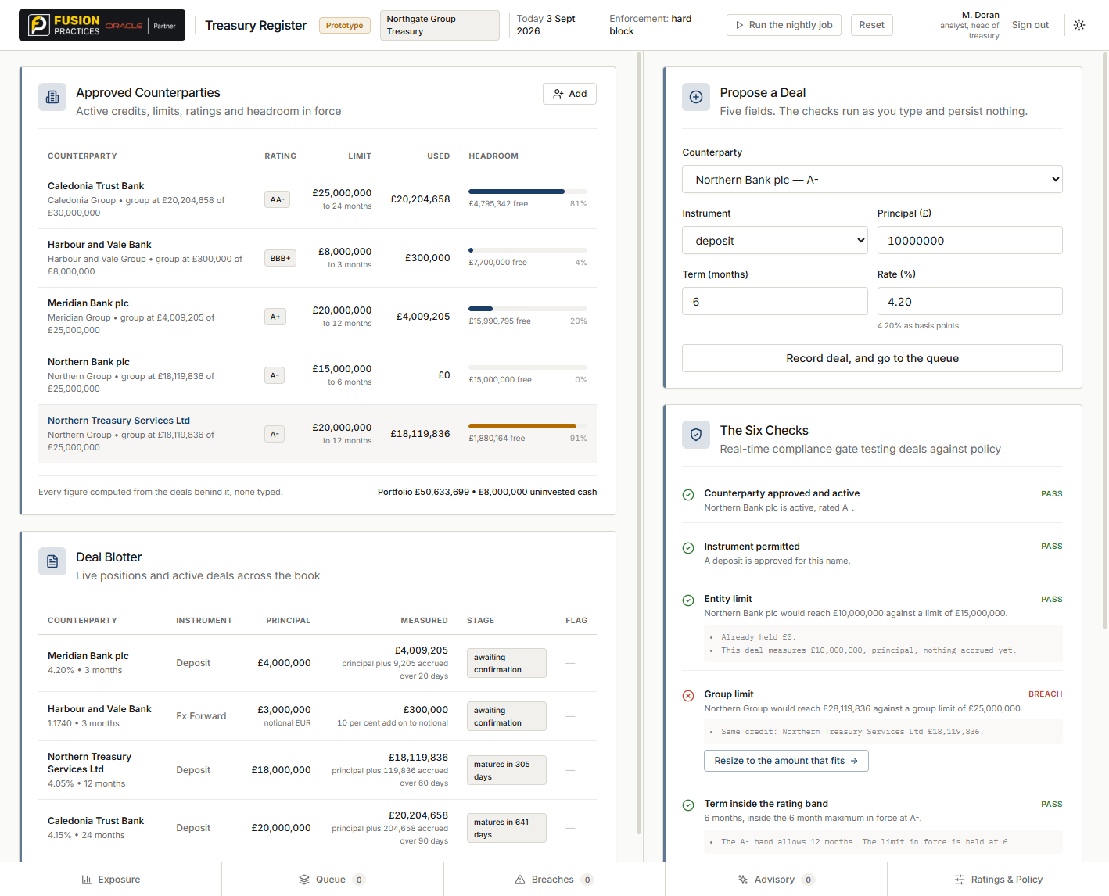
Figure 4. Propose a Deal — a failing verdict, with a resize offered.

What it is
The same ticket as the previous screen, this time with a Northern Bank deposit of £10,000,000 over 6 months. Both entity checks pass — Northern Bank plc alone has room — but Northern Group hits its limit because Northern Treasury Services Ltd already sits at £18,119,836 against a £25,000,000 group ceiling.

How to get here
Change the counterparty or increase the principal until a check fails. The verdict updates without pressing anything.

What you do here
- Read the failing check. It states the arithmetic: what the group would reach, and against what limit.
- If a resize would fit, a button appears with the amount that would fit. Clicking it fills the ticket in but records nothing — the resize is your decision, not the system's.
- Recording the deal anyway sends it to the Queue with a reason code, where it can be Resized, Rerouted, Overridden (only under a warn-with-override policy) or Cancelled.

05. Exposure — Counterparty tab
STAGE The watch stage. Cross-cutting view of how much of the book each counterparty and each group holds.
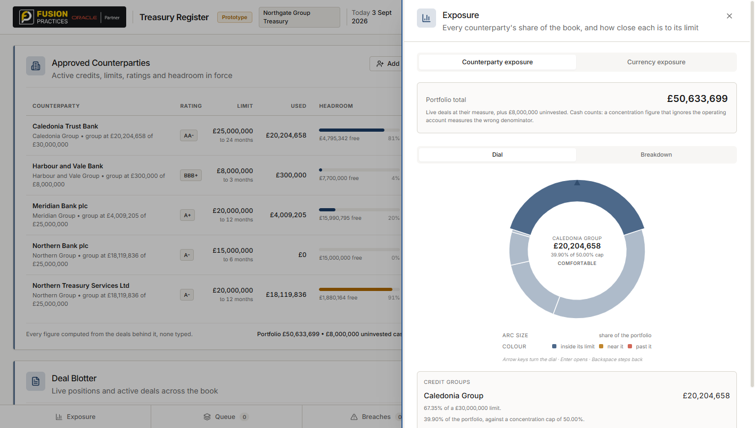
Figure 5. Exposure — Counterparty tab.

What it is
Behind the Exposure button on the strip. Two tabs: Counterparty exposure (here) and Currency exposure. The dial is the central control: each wedge is a group's share of the portfolio, sized by share and coloured by how close the group is to its own limit. Turning the dial with the arrow keys, or clicking a wedge, names the group in the centre with a plain-word status: Comfortable, Watching, At the cap, or Over.

How to get here
Click Exposure on the strip along the bottom. It opens as a right-hand panel.

What you do here
- Read the portfolio total at the top: every live position at its measured value, plus the uninvested cash sitting in the operating account.
- Turn the dial or click a wedge to inspect a group. The centre shows its share of the book, its status against the concentration cap, and — in the card below — how much more the group could hold before hitting the cap.
- Drill in by clicking the same wedge twice: the inner ring appears, showing the counterparties inside that group.
- Switch to the Breakdown tab for a flat table of the same figures if a list is faster than a picture for the current question.

06. Exposure — Currency tab
STAGE The watch stage. The other kind of exposure: what the business owes in each currency, and how much of it a forward covers.
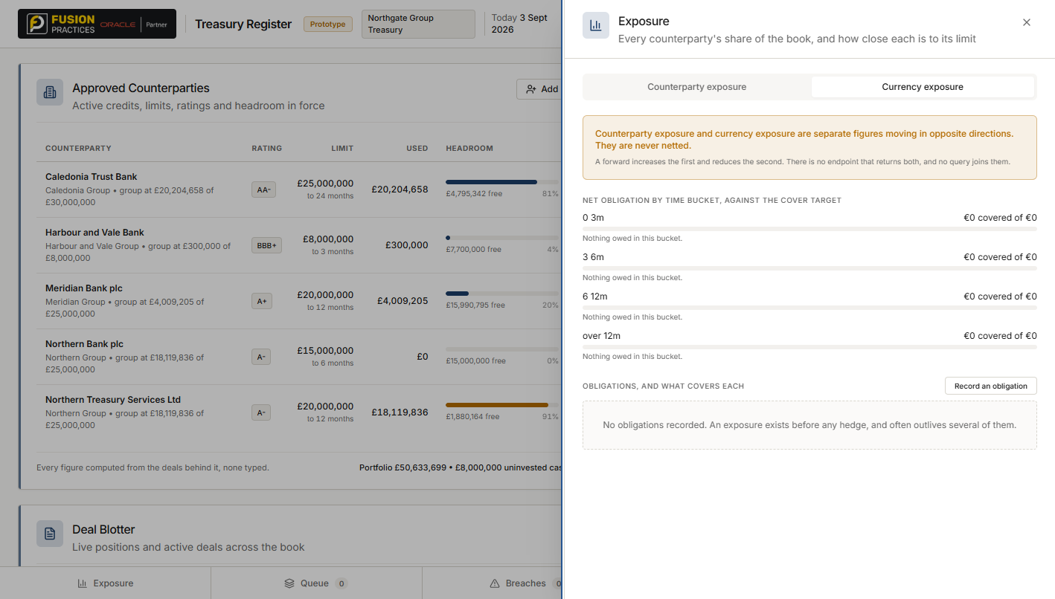
Figure 6. Exposure — Currency tab.

What it is
The second tab of the Exposure panel. Four time buckets, each with a coverage bar against a target percentage. Below them, every obligation the treasury has recorded, with the forwards linked to it indented beneath.

How to get here
Exposure panel → Currency exposure tab at the top.

What you do here
- Read the buckets to see when currency demand is coming due and how much of it is covered.
- Record an obligation to add a new one — a purchase order, an invoice, a forecast, or a contract.
- Link a forward on an obligation row to cover it. The link creates the coverage; forwards on their own are not covering anything until they are linked.
- Unlink any hedge with a reason (rolled, closed early, exposure cancelled, reallocated). Coverage recomputes and status can move backwards — that is correct behaviour, not an error.
- The warning at the top of the tab is important: counterparty exposure and currency exposure are separate figures that move in opposite directions and must never be netted.

07. Queue — a limit failure
STAGE Post-refusal, pre-decision. A deal that failed the checks becomes a piece of work with a reason code, waiting to be resolved.
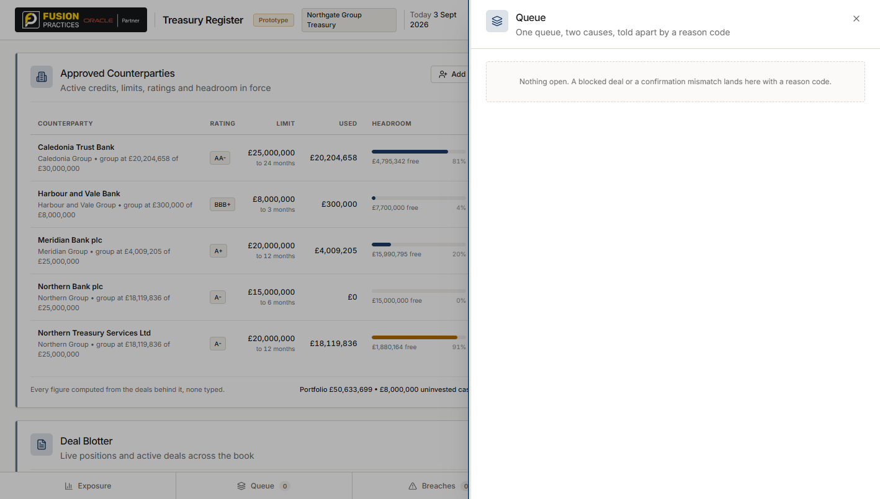
Figure 7. Queue — a limit failure.

What it is
Behind the Queue button on the strip. The badge on the strip button shows the count, so a busy queue is visible from the dashboard.

How to get here
Click Queue on the strip. Or, when a deal is refused, the strip shows Queue 1 immediately.

What you do here
- Read the reason code. Every item is headed by its cause, then a specific reason: LIMIT FAILURE · TENOR BAND, or GROUP LIMIT, or CONCENTRATION.
- The arithmetic is on the item: what the deal would have reached, against what limit.
- Pick a resolution. A limit failure offers Resized, Rerouted, Override (only under a warn-with-override policy) and Cancelled. Each writes an audit record of what was decided and why.
- The item disappears from the queue on resolution. The evidence stays.

08. Breaches
STAGE The watch stage. When the world moves — a rating downgrade, a limit tightening — a position that was fine yesterday can be outside its limit today. This is where those show.
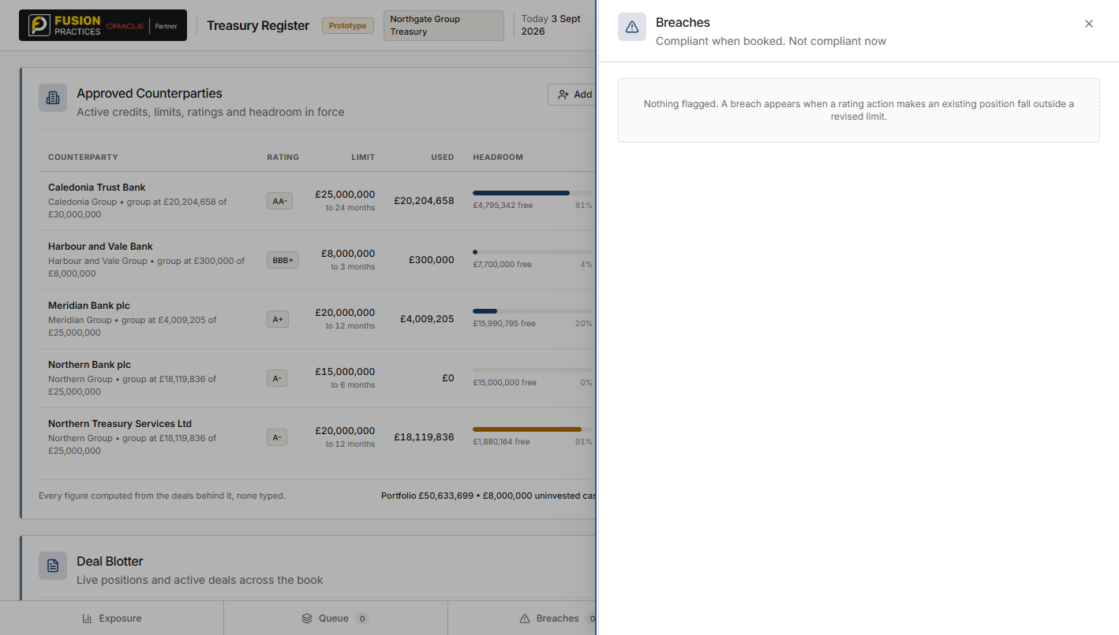
Figure 8. Breaches.

What it is
Behind the Breaches button on the strip. The badge shows the count. In a healthy book it is empty; a breach means somebody has to decide what to do.

How to get here
Click Breaches on the strip.

What you do here
- Read each breach. It names the position, the counterparty, the old and new limits, and the amount that is now outside them.
- A breach is raised rather than unwound. The position is real and the decision — reduce, reroute, negotiate, wait — is a person's, not the system's.
- Breaches usually come from the Ratings & Policy panel. A downgrade tightens the limit for that name to its new band's ceiling, and any position over the new limit raises a breach.

09. Advisory
STAGE Cross-cutting. The only part of the system that calls a language model. Proposes deals, does not write them.
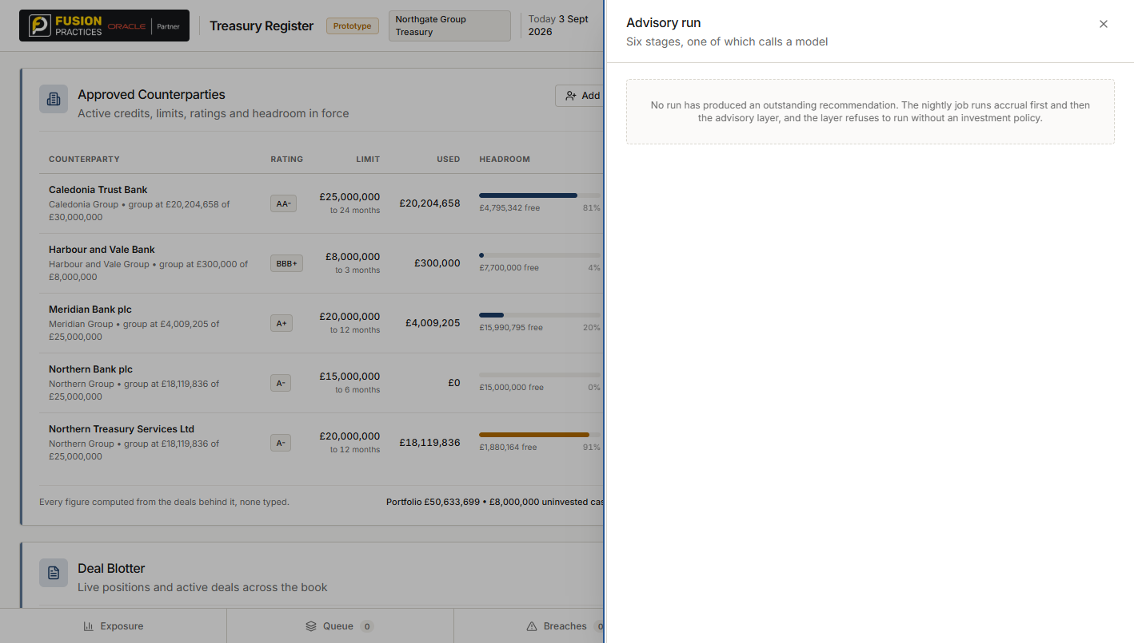
Figure 9. Advisory.

What it is
Behind the Advisory button on the strip. The badge shows how many candidates the last run produced. Each candidate names the counterparty, the terms, and a short reasoning line.

How to get here
Click Advisory on the strip. The last nightly run's candidates are shown; See the full run opens the six-stage detail on top.

What you do here
- Read a candidate. It is a suggestion, priced against the current book, with reasoning behind it.
- Accept and load the ticket loads a candidate into Propose a Deal, where the six checks run again from scratch. Nothing is booked until you click Record.
- Reject a candidate and you are asked to say why. The reason is kept — the record of what was declined is as useful as the record of what was taken.

10. Advisory — the full run
STAGE Cross-cutting. The six stages of a run, showing which one calls the model and which do not.

Figure 10. Advisory — the full run.

What it is
Detail overlay on the Advisory panel. The six stages are Detect the gap, Assemble context, Build candidates, Rank and explain, Validate, and Accept or edit. Five are marked Deterministic; only Rank and explain is marked The model.

How to get here
Advisory panel → See the full run at the top.

What you do here
- Notice which stages are deterministic. The model ranks options the deterministic code has already built and already checked. It cannot invent a counterparty, exceed a limit, or write a deal.
- If the model is unavailable or returns something malformed, the run falls back to a weighted score and the outcome says so.
- This is where the edge from advisory to the book is drawn as a dashed line: the advisory layer proposes, and the ordinary deal path — with its six checks — disposes.

11. Ratings & Policy
STAGE Cross-cutting. Where a downgrade or an upgrade is recorded, and where the enforcement policy is set.
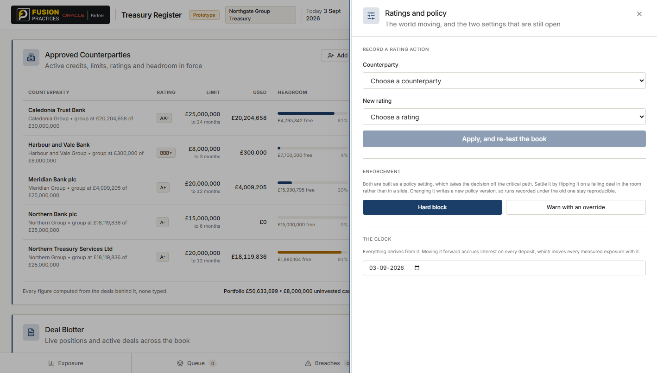
Figure 11. Ratings & Policy.

What it is
Behind the Ratings & Policy button on the strip. Two sections: Record a rating action, and the current policy in force.

How to get here
Click Ratings & Policy on the strip.

What you do here
- Record a rating action. Choose a counterparty, choose a new rating, click Apply, and re-test the book. Every position for that counterparty is re-tested against its new band.
- A downgrade tightens the limit automatically to the new band's ceiling. An upgrade does NOT automatically widen the limit — a widening is a decision, and a person has to make it. If a rating agency held that pen, the treasury would have no credit appetite of its own.
- The policy section shows the concentration cap, the enforcement mode (hard block, or warn with override), and the approval thresholds. Changing it re-tests the book too.

12. The deal panel — the lifecycle rail
STAGE Every stage of one deal, in one place. Capture through to close, with the boundary of the system drawn on screen.
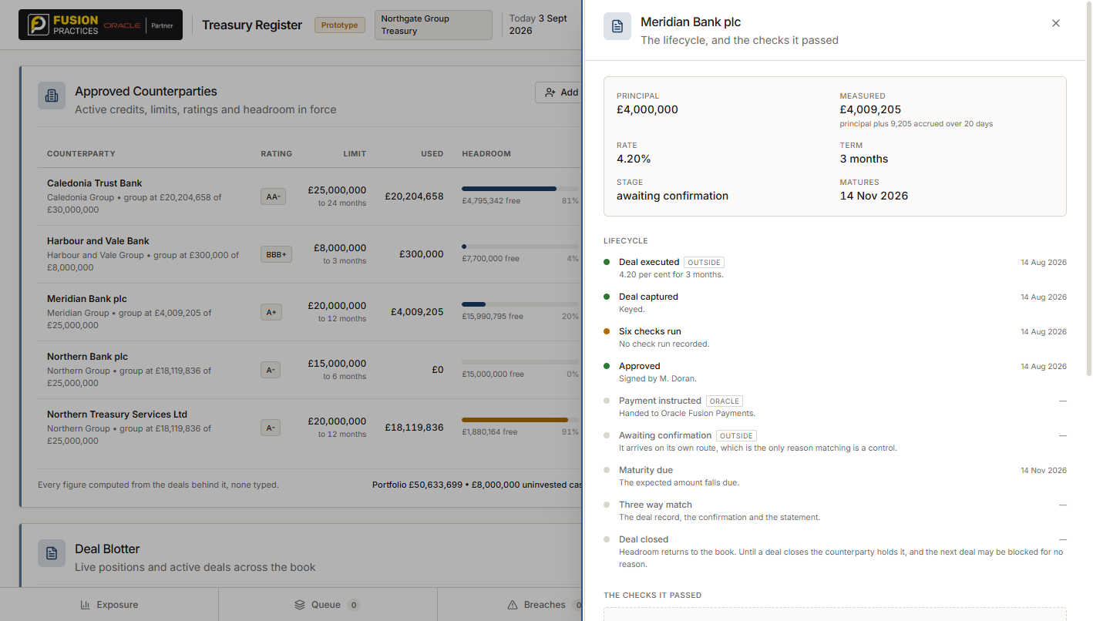
Figure 12. The deal panel — the lifecycle rail.

What it is
Behind any row in Deal Blotter. Header states the deal's Principal, Measured value, Rate, Term, Stage and Maturity. The Lifecycle rail below lists every step: Deal executed, Deal captured, Six checks run, Approved, Payment instructed, Awaiting confirmation, Maturity due, Three way match, Deal closed.

How to get here
Click any row in Deal Blotter on the dashboard.

What you do here
- Read the header for the current state. Measured is principal plus interest accrued to today.
- Read the rail for the history. Steps outside the system are tagged OUTSIDE; steps handled by Oracle are tagged ORACLE. The boundary of the system is drawn on screen rather than hidden.
- Every section below the rail — The checks it passed, The counterparty's record, the confirmation, the amendments, the settlement, the accruals, the journals — is part of the same panel. No section is behind another click.

13. The confirmation section — mismatched
STAGE The confirm stage. A confirmation has arrived, and one field disagrees with what was keyed.
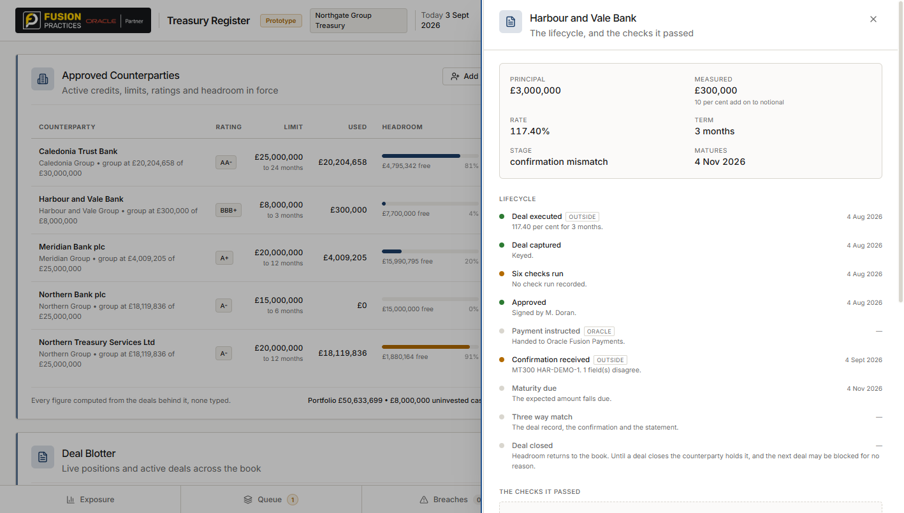
Figure 13. The confirmation section — mismatched.

What it is
Inside the deal panel, between the counterparty record and the amendments. Header says MT300 with a reference, and MISMATCHED. A table underneath: Field, Keyed, Confirmed.

How to get here
Deal panel → scroll to the section headed by the confirmation type (MT300, MT320, and so on).

What you do here
- Read the table. One row per field that disagreed. A forward rate reads as an exchange rate (1.1740), not a percentage — the same column holds an interest rate for a deposit and an exchange rate for a forward, and the panel knows which is which.
- The mismatch is also raised as a Queue item with cause CONFIRMATION MISMATCH — see the next screen.
- Resolve from the queue: Correct the deal takes the confirmed terms and re-runs the six checks (a corrected rate can change the exposure); Challenge the bank leaves the deal untouched and the confirmation disputed; Cancelled ends the deal.

14. Queue — a confirmation mismatch
STAGE Post-confirmation. The same queue that carries a limit failure now carries a mismatch, told apart by its cause code.
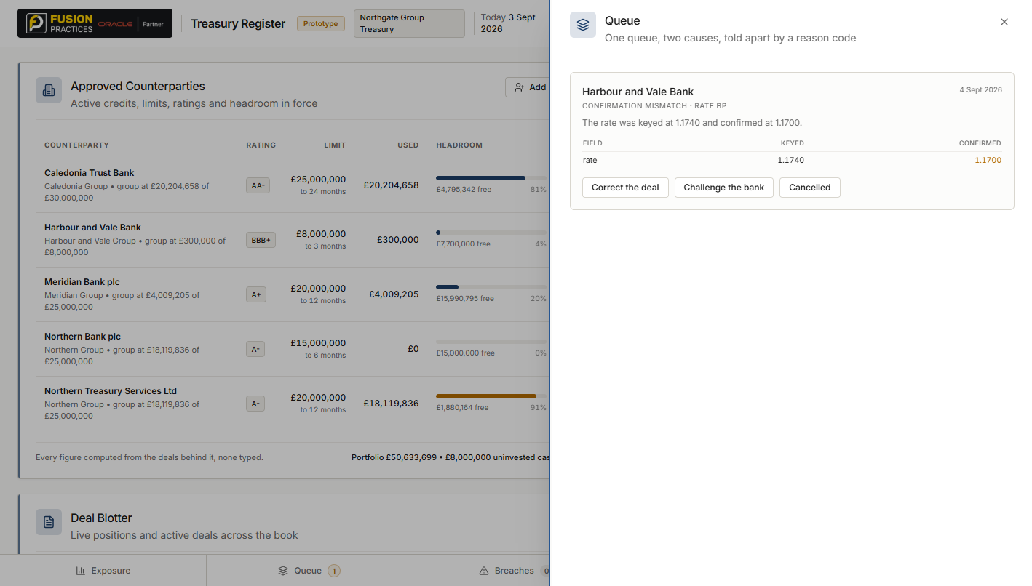
Figure 14. Queue — a confirmation mismatch.

What it is
Behind the Queue button on the strip. The badge shows the total; each item names its cause. A LIMIT FAILURE and a CONFIRMATION MISMATCH share this one queue because a treasurer's day is one queue.

How to get here
Click Queue on the strip. Or, when a mismatch is ingested, the strip shows Queue 1 immediately.

What you do here
- Read the difference. Field, Keyed, Confirmed — one row per field that disagreed. This is the record of what to negotiate.
- The three mismatch resolutions are the only ones offered: Correct the deal, Challenge the bank, Cancelled. A mismatch is not fixed by the resolutions a limit failure offers, so those buttons are absent rather than refused on click.
- Notice the fx forward rate reads as 1.1740, not 117.40 per cent. This is the fix that was made to the renderer: `rate_bp` holds different things for different instruments, and the renderer now asks the deal which one.

15. The amendment section — raising a change
STAGE The amend stage. A change to a live deal, recorded as an entry rather than an edit.
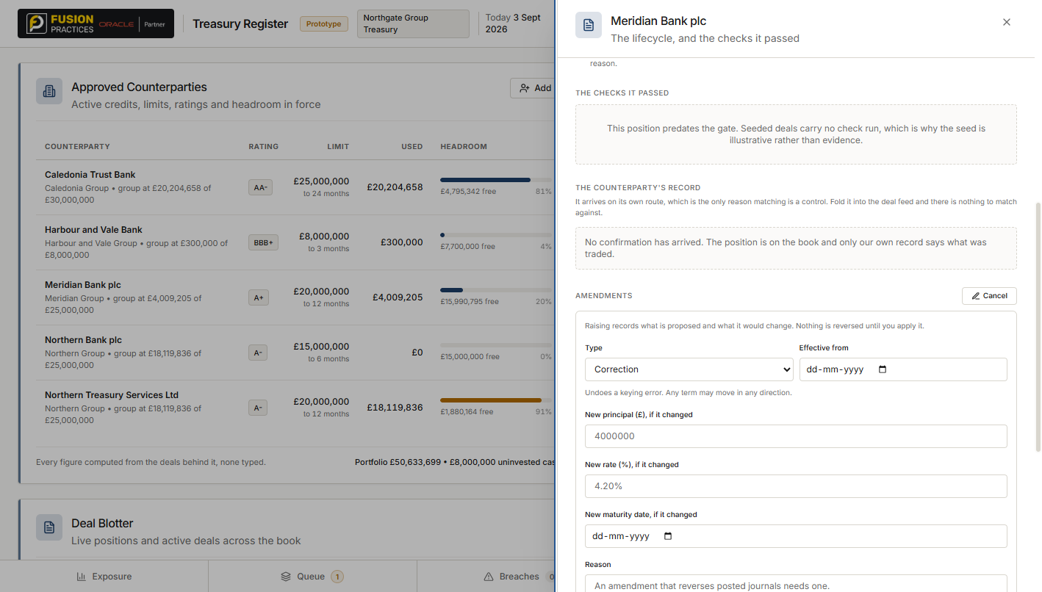
Figure 15. The amendment section — raising a change.

What it is
Inside the deal panel, below the confirmation. Clicking Raise one opens the form. The form shows only the fields the chosen type is allowed to move: a correction offers principal, rate and maturity; a roll offers maturity; a partial drawdown offers only a smaller principal; a break carries no new terms.

How to get here
Deal panel → scroll to the AMENDMENTS section → Raise one.

What you do here
- Choose a Type. Each type has a one-line hint under it describing what it does, because the type is the word that appears in the audit trail and choosing the wrong one is an audit problem, not a UI problem.
- Set Effective from. Everything recognised on or after this date will be reversed and reposted at the new terms.
- Enter the fields the type shows. Blank means unchanged. The form refuses combinations that the type does not allow (a drawdown that grows, a roll with no later maturity).
- Raise, and show what it would change. This is a preview: how many days would be reversed, for how much, and which accounting periods are touched. Nothing has changed yet.
- Apply. Re-test, reverse and repost. The six checks re-run first — an amendment is a new decision about a position, not a data fix, so a principal that no longer fits is refused. Only then is the reversal written.

16. The settlement section — three-way match
STAGE The settle stage. The deal, the confirmation, and the bank statement have to agree before the deal closes and the counterparty releases its headroom.
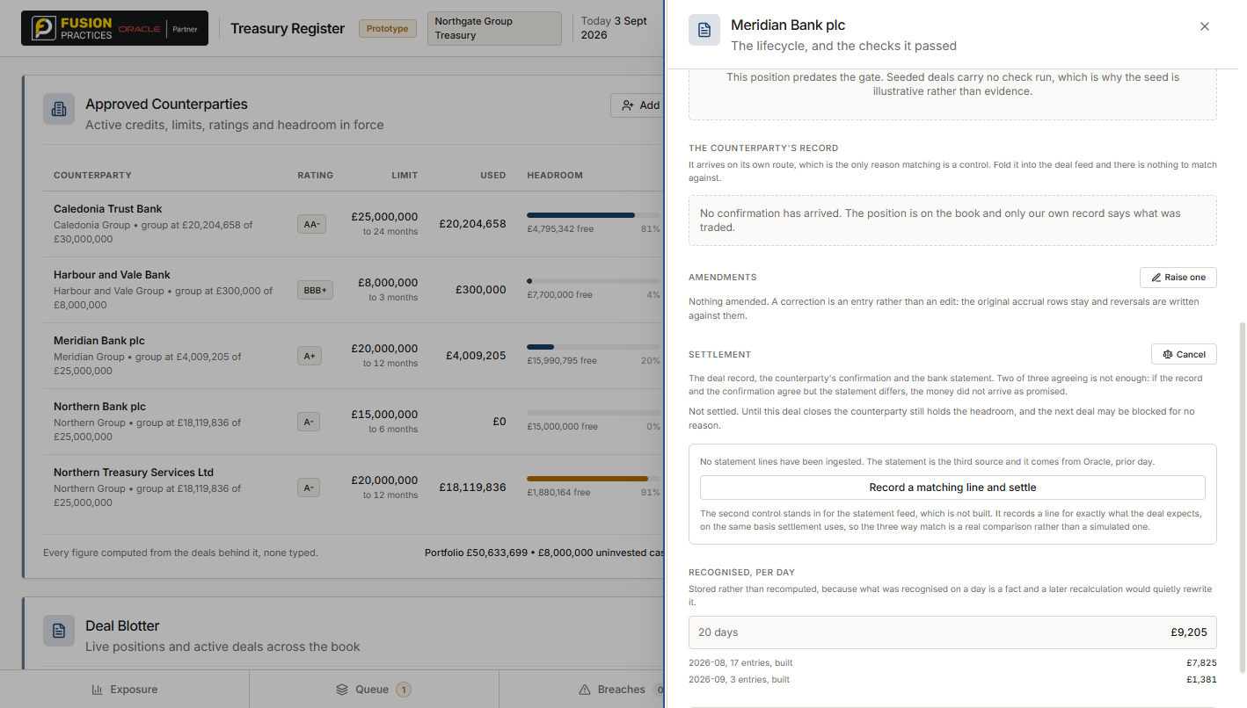
Figure 16. The settlement section — three-way match.

What it is
Inside the deal panel, the last section before the accruals and journals. Clicking Match three sources opens it. Three figures are shown: Record, Confirmation, Statement.

How to get here
Deal panel → scroll to the SETTLEMENT section → Match three sources.

What you do here
- Read the three figures. Two of three agreeing is not enough. If the record and the confirmation agree but the statement differs, the money did not arrive as promised — and that is exactly the case two-way matching cannot see.
- Match against this line matches the deal to an existing ingested statement line.
- Record a matching line and settle is the demonstration button, standing in for the bank statement feed. It records a line for exactly what the deal expects, so the three-way match is a real comparison rather than a simulated one.
- On All three agree the deal moves to closed, and the counterparty's headroom returns to the book. Until this happens the counterparty still holds the room and the next deal may be blocked for no reason at all.

One line worth remembering
Every path that puts a position on the book — keying a deal, correcting one against a confirmation, amending one — goes through the same six checks and writes a check run. Screens 3, 13 and 15 are three faces of the same gate. There is no side door.

Treasury Register · interface walkthrough · book dated 3 September 2026

